~

CONSULTATION CAR RENTAL SYSTEM

|  |  |  |  |
| --- | --- | --- | --- |
| No. | Student ID | Student Name | Role |
| 1. | 1221202705 | Ngeo Jia Jet | Leader |
| 2. | 1221203269 | Loh Grierius | Member |
| 3. | 1221203781 | Teh Chi Siong | Member |

Trimester 1, Session 2023 / 2024 FACULTY OF COMPUTING AND

INFORMATICS MULTIMEDIA UNIVERSITY

JULY 2024

**COPYRIGHT ©**

© 2017 Universiti Telekom Sdn. Bhd. ALL RIGHTS RESERVED.

Copyright of this report belongs to Universiti Telekom Sdn. Bhd. as qualified by Regulation 7.2 (c) of the Multimedia University Intellectual Property and Commercialisation Policy. No part of this publication may be reproduced, stored in or introduced into a retrieval system, or transmitted in any form or by any means (electronic, mechanical, photocopying, recording, or otherwise), or for any purpose, without the express written permission of Universiti Telekom Sdn. Bhd. Due acknowledgement shall always be made of the use of any material contained in, or derived from, this report.

# ACKNOWLEDGEMENT

I would like to express my deepest gratitude to Madam Suraya for her exceptional guidance and supervision of our final year project group. Her unwavering support and insightful feedback have been invaluable to our progress and success.

Additionally, I would like to extend my heartfelt thanks to Mr. Ngeo Jia Jun for his tremendous assistance in developing our database and PHP components. His expertise and dedication played a crucial role in bringing our project to fruition.

Thank you both for your contributions and support.

# ABSTRACT

Our project is a website-based project using components such as PHP, JavaScript, HTML and CSS. At the end of the project, we managed to make a platform that can be used more efficiently such as sorting the car using car type or something like the feedback page that can send the feedback to administrators or developers. We provide an easy, faster and simple platform on the Car Rental Website. This website allows users to rent a car, make payments and edit profile etc. For admin, this website allows it to view the car, add the car and see the payment etc.

# LIST OF TABLES

**Table 1.1:** *Division of tasks* *…………………………………………………***17**

**Table 5.1：***System Testing …………………………………………………51*

ACKNOWLEDGEMENT 2

ABSTRACT 4

LIST OF TABLES 5

LIST OF FIGURES 6

For Research I have done before,I mentioned some of website is to laggy for using.We doing this resource is to learn how to design the CarRental Website.This time the website I use for our primary study is SurialCarRental .The Website is clean but in my opinion it looks like it's not simple enough for customers. 16

# LIST OF FIGURES

**Figure 1.1:** *Sample website screenshot* *………………………………………………* 22

If the figure exists in Part 2, it should be referred as Figure 2.x where x is an integer based on the order of appearance.

**Table of Contents** *(kindly change the page number accordingly)*

**COPYRIGHT i**

**ACKNOWLEDGEMENT ii**

**ABSTRACT iii**

**LIST OF TABLES iv**

**LIST OF FIGURES v**

**TABLE OF CONTENTS vi**

**PART 1: INTRODUCTION 1**

1.1 Overview 12

1.2 Project Objectives 12

1.3 Target User 13

1.4 Project Scope 13

1.5 Gantt Chart 1 14

1.6 Gantt Chart 2 14

1.7 Division of Work 15

**PART 2: PRIMARY STUDY AND LITERATURE REVIEW** **16**

2.1 Primary Study 17

2.2 Problem Statement 20

**PART 3: SYSTEM DESIGN**  **21**

3.1 System Features 22

3.2 Hardware/Software Requirements 23

3.2.1 For Developer

3.2.2 For User 23

3.3 Context Diagram & Data Flow Diagram 24

3.4 Entity Relationship Diagram 25

3.5 Data Dictionary 25

**PART 4: SYSTEM PREVIEWS** 27

4.1 Customer/Member Module 29

4.2 Staff/Admin/Front Desk Module 44

**PART 5: SYSTEM TESTING**  **49**

5.1 System Testing 50

**PART 6: CONCLUSION** **55**

6.1 Conclusion 56

**PART 7: REFERENCES** **57**

**PART 8: APPENDIX** **60**

Appendix A: Minutes of Meeting 61

Appendix B: Website Samples/Questionnaire/Forms 62

Appendix C: Request Interview Letter 62

Appendix D: Interview Questions 63

Appendix E: Client/Server Setup Guide 63

Appendix F: CD (Softcopy of Report and System) 63

*Part I:*

*Introduction*

* 1. **Overview**

In an era where convenience and accessibility are paramount, the need for efficient and user-friendly systems within the automotive industry has never been more critical. This report presents the development of a comprehensive web-based car rental system designed to streamline the process of renting vehicles for both customers and administrators.

The primary objective of this project is to create a robust and intuitive platform that facilitates the rental process from start to finish. This system aims to provide customers with a seamless experience for browsing available vehicles, making reservations, managing bookings, and accessing support, while also offering administrators the tools they need to efficiently manage inventory, track reservations, and oversee the entire rental process.

The development of this system will leverage a combination of technologies to ensure functionality, scalability, and security. This includes:

- HTML, CSS, and JavaScript for building the user interface and enhancing the user experience.

- PHP for server-side scripting to handle dynamic content generation and database interactions.

- MySQL for the database management system to store and retrieve data related to vehicles, reservations, customers, and administrative tasks.

Key features of the car rental system will include:

- User authentication and authorization to ensure secure access to the system.

- An intuitive interface for browsing vehicle inventory, including search and filtering options.

- Booking management functionality for users to reserve vehicles based on their preferences and availability.

- Administrative tools for managing vehicle listings, user accounts, reservations, and rental transactions.

- Integration of payment gateways to facilitate secure online transactions for rental fees.

- Responsive design to ensure optimal performance across various devices and screen sizes.

By developing a web-based car rental system that prioritizes usability, efficiency, and security, we aim to meet the evolving needs of both customers and administrators within the automotive rental industry. Through the utilization of modern technologies and best practices in software development, we strive to deliver a solution that enhances the overall rental experience while driving operational effectiveness and business growth.

* 1. **Project Objectives**

1. Implement online booking and payment functionally, supporting different types of rental needs such as long-term, short-term, and scheduled pick-up.

2. Contact with management to handle user inquiries and complaints.

3. Provide a more smooth platform for users.

* 1. **Target Users**

1. Travelers in Malaysia: Our primary focus is on providing a simple and efficient way for outsiders to enjoy their trips within Malaysia. Whether tourists exploring the cultural richness of our nation or adventure-seekers traversing its natural landscapes, our platform aims to facilitate seamless travel experiences tailored to their preferences.
2. Elderly Individuals: Recognizing the unique requirements of elderly individuals, we strive to offer an easy and accessible solution for them to enjoy their trips with comfort and convenience. Our user-friendly interface and personalized assistance cater to their needs, ensuring a hassle-free and enjoyable travel experience.
3. Business Professionals: For busy businessmen navigating their professional commitments within Malaysia, we offer a convenient solution by providing rental cars and drivers. Our services aim to streamline their travel logistics, allowing them to focus on their work without worrying about transportation arrangements. Whether attending meetings, conferences, or exploring business opportunities, our platform offers a reliable and efficient mode of transportation.
   1. **Project Scope**

1. The scope of the software product developed involves paid service to the customers for renting a number of cars that are being offered

2. It involves a very simple registration to be done by the admin or the system manager.

3. Provide a car catalog for users as an alternative for them to select a car if they want to choose a car on their own

* 1. **Gantt Chart 1**

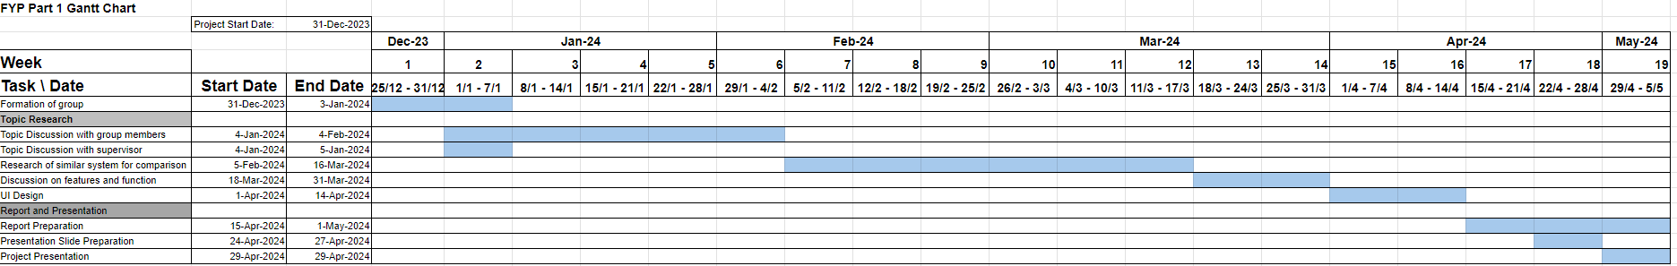

***Figure 1.5 Gantt Chart 1***

* 1. **Gantt Chart 2**

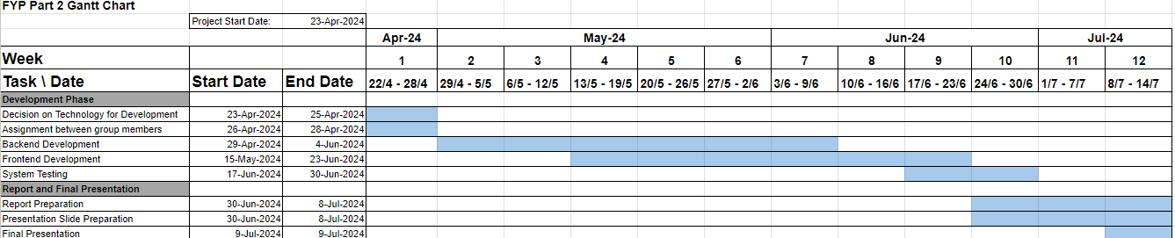***Figure 1.6 Gantt Chart***

[GanttChart](https://docs.google.com/spreadsheets/d/19kXKvw0KLU4SGH_NasVIkfChpUDvTCCPJAwyNj24Mo/edit?usp=sharing)

* 1. **Division of Work**

|  |  |  |  |
| --- | --- | --- | --- |
| **TASKS** | **STUDENTS** | | |
|  | Teh Chi Siong | Ngeo Jia Jet | Loh Grierius |
| Preparing project proposal | X | X | X |
| Overview |  | x |  |
| Objectives | x |  | x |
| Target Users | x | x | x |
| Project Scope | x |  | x |
| Gantt chart | x |  |  |
| Primary Study | x | x | x |
| Problem Statements | x |  | x |
| System Features | x |  | X |
| Hardware/Software Requirements | x | x | x |
| Data flow diagram & Context Diagram |  | x |  |
| Entity relationship diagram |  | X |  |
| Data dictionary |  | x |  |
| System Interface Design | X | X | X |
| System Coding | X | X | X |
| System Testing | x | X | X |
| Compilation of Final Report | x |  | X |
| Presentation and Demo |  |  | X |
| Meeting Minutes |  | x |  |

**Table 1.1:** *Division of tasks*

*Part II:*

*Primary Study And*

*Literature Review*

* 1. **Primary Study**

For Research I have done before,I mentioned some of website is to laggy for using.We doing this resource is to learn how to design the CarRental Website.This time the website I use for our primary study is SurialCarRental .The Website is clean but in my opinion it looks like it's not simple enough for customers.

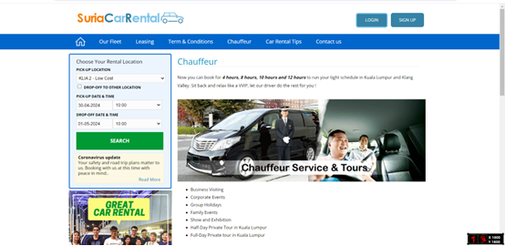

***Figure 2.1******Suria Car Rental***

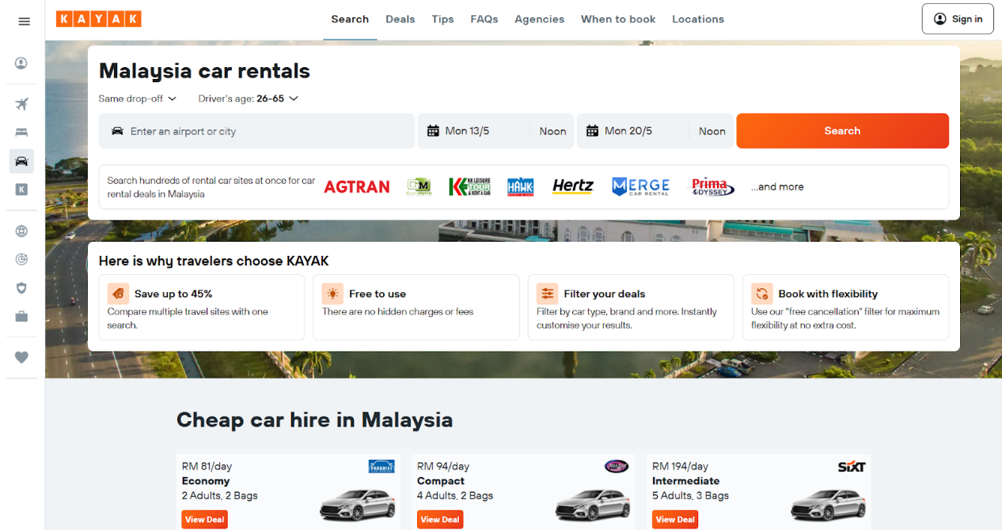

***Figure 2.2 Kayak of booking system***

This website includes accommodation,flight booking, car rental systems,etc.

Beside that,this website is combined with other services to let travelers or users come to certain places and can easily get their transport.

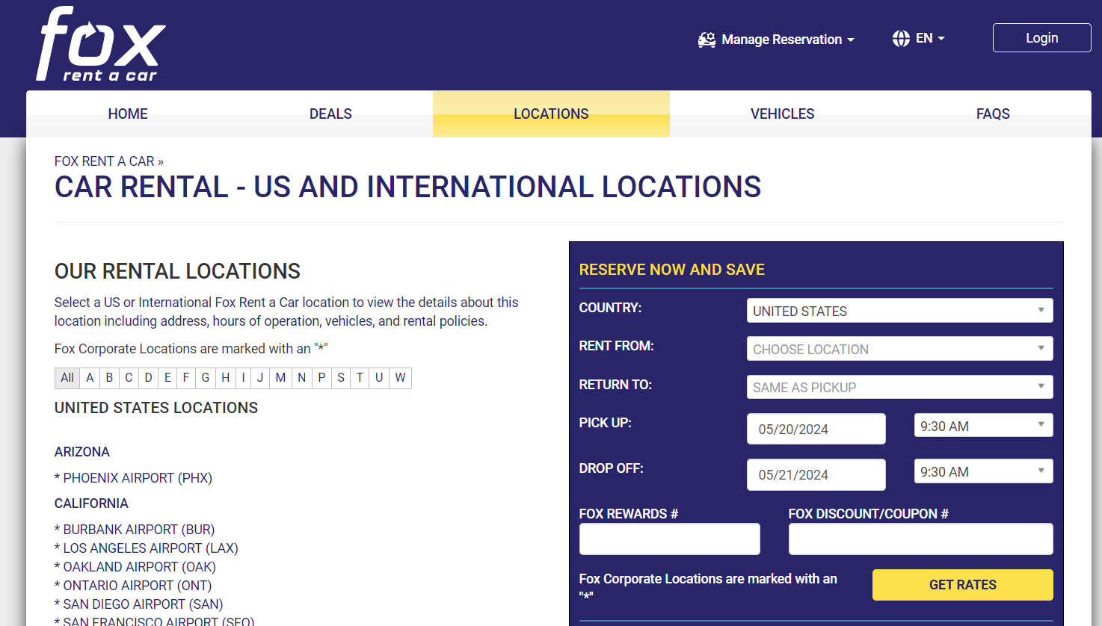

***Figure 2.3 Fox rent a car***

This screenshot shows FOX car rental website location page.In this page we found it only provide quite limited location to US and international locations

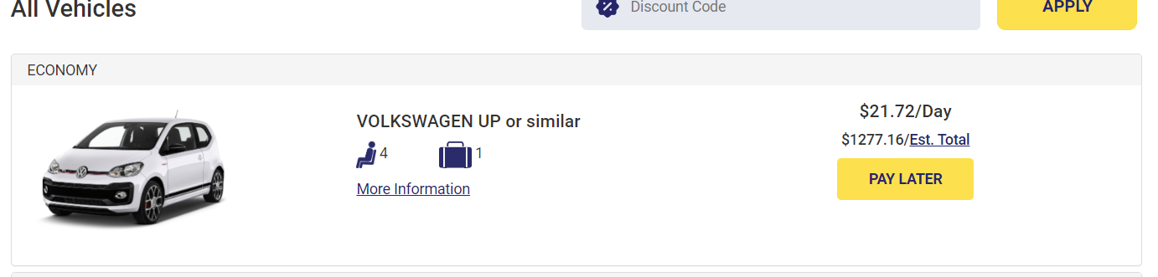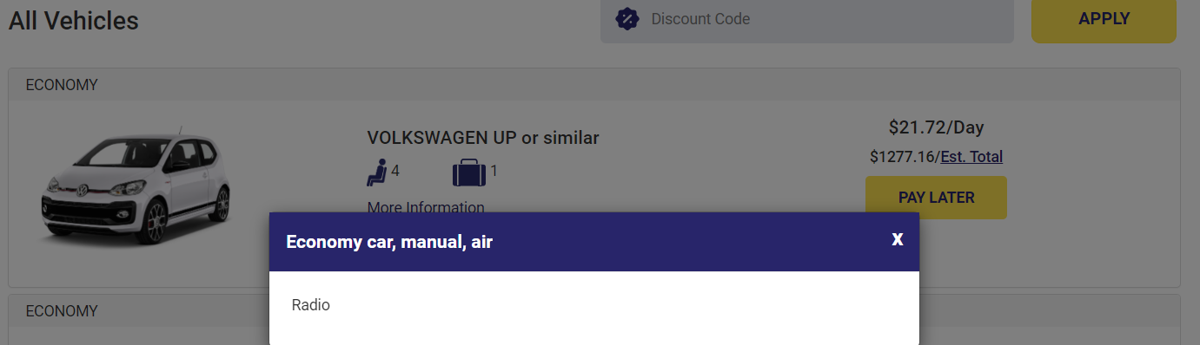We can see from these two screenshots that the information on the car is too little.

* 1. **Problem Statement**

***Objective:***

Implement online booking and payment functionally, supporting different types of rental needs such as long-term, short-term, and scheduled pick-up.

***Problem Statement:***

Current vehicle management systems lack a centralized database for storing comprehensive vehicle information, leading to difficulties in tracking availability, pricing, and maintenance schedules. This results in operational inefficiencies, including overbooking, inaccurate pricing, and vehicle downtime due to maintenance delays.

***Objective:***

Direct chat box with management to handle user inquiries and

complaints.

***Problem Statement:***

Existing rental platforms lack flexible booking options and secure payment gateways, making it challenging for users to book vehicles according to their specific needs, such as long-term rentals or scheduled pick-ups. This inconvenience hampers user experience and leads to lost business opportunities for the rental service provider.

***Objective:***

Provide a more smooth platform to users.

***Problem Statement:***

We should make the market bigger to let people outside Malaysia also use our platform to rent cars in their country.

*Part III:*

*System Design*

* 1. **System Features**

List down all features of the proposed system for each type of user.

Example:

* Admin
* Login
* Edit profile
* Add, edit, delete car information
* Add, edit, delete promotion code
* View the feedback from user
* Delete the post inside the blog
* Reply the message from user
* Edit the guide
* Member
  + Can register and log into the system.
  + Edit profile
  + View list of cars
  + Choose pickup and return location
  + Filter list of cars
  + Rent a car
  + View rental history
  + Book reservation
  + Make a review
  + Contact with customer service
  + Make payment
  1. **Hardware/Software Requirements**
     1. **For Developer**

The CPU needed to be 4 core and above, RAM needed at least 8GB, having a cloud server and domain. Storage needed is at least 20gb.

* + 1. **For User**

Users only need a web browser that supports JavaScript and html5 to run our website and stable network to access our website.

* 1. **Context Diagram & Data Flow Diagram**

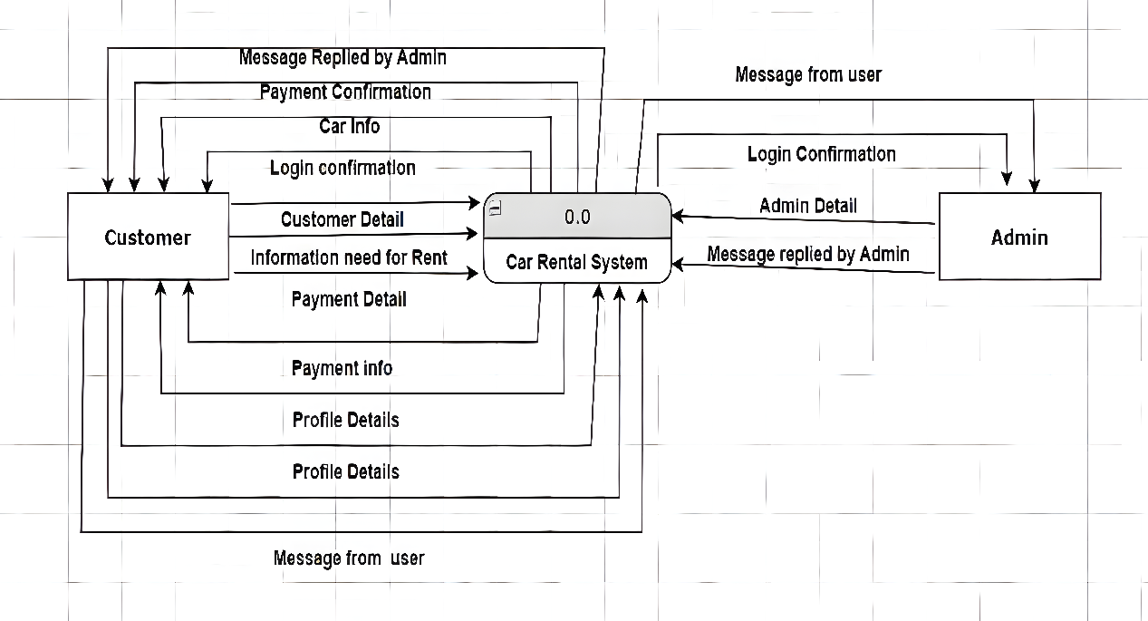

**Data Flow Diagram**

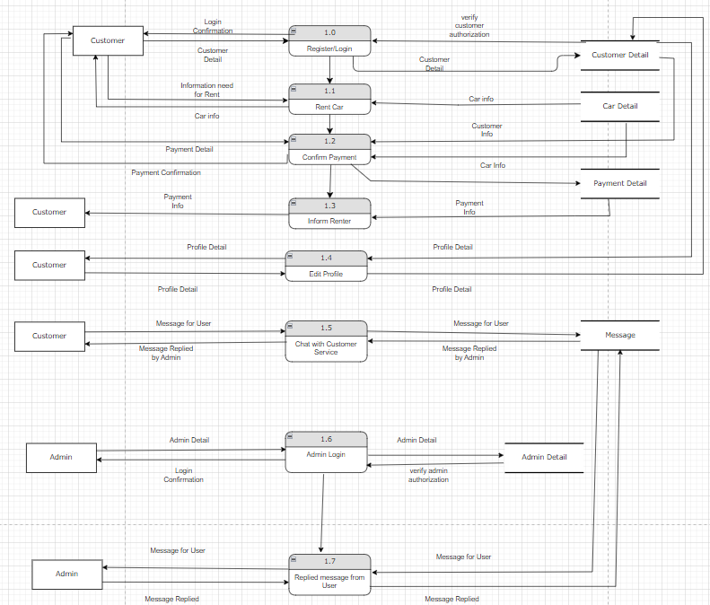

* 1. **Entity Relationship Diagram**

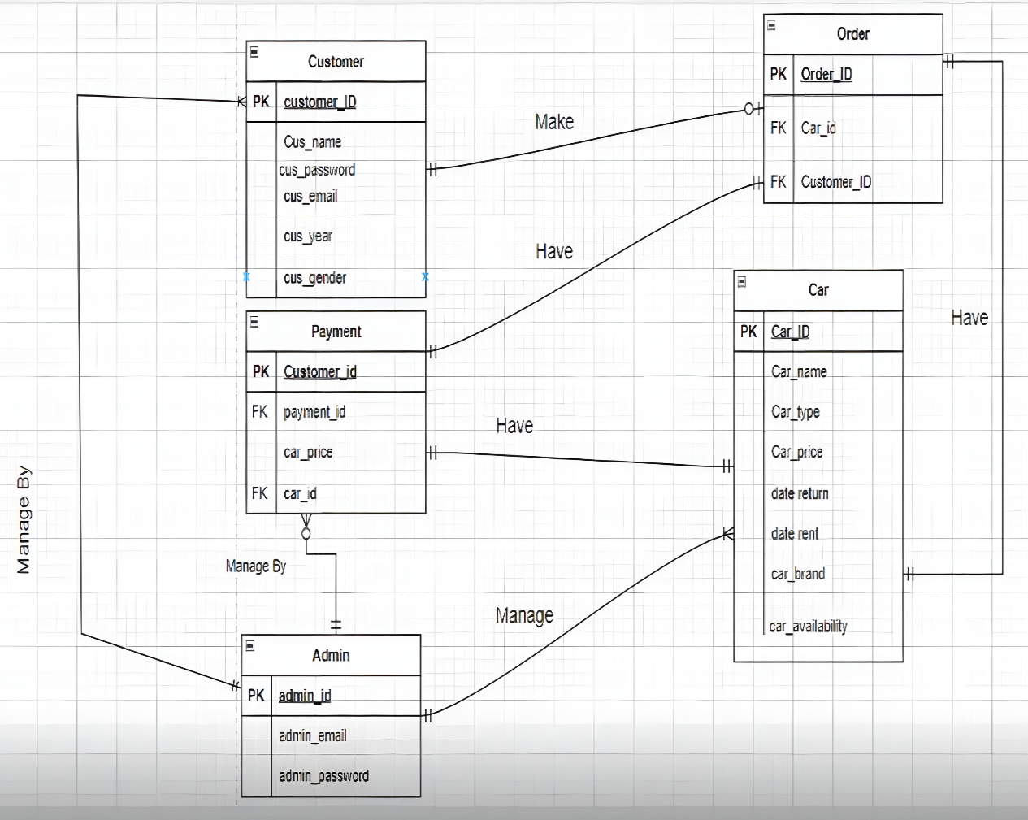

* 1. **Data Dictionary**

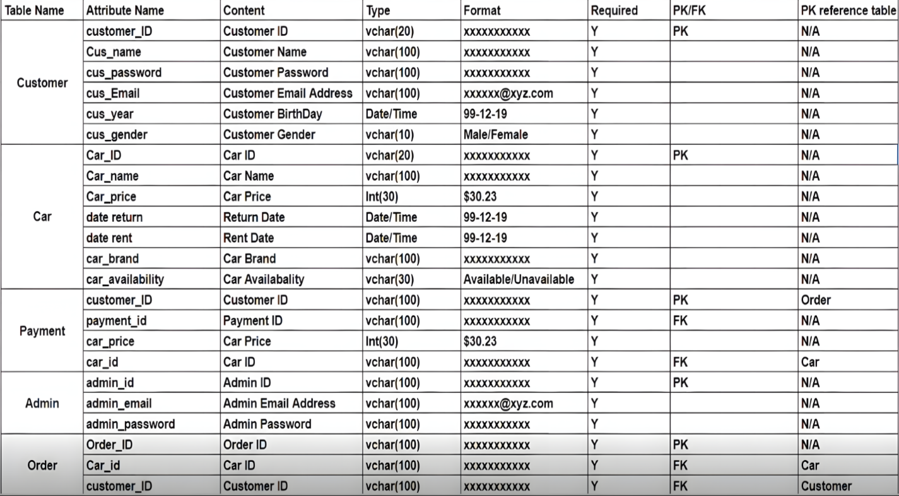

**Link to** [**Data Dictionary**](https://mmuedumy-my.sharepoint.com/:i:/g/personal/1221202705_student_mmu_edu_my/ER__6GbCZ1tBg9NHU1HKeLYBrbN9rOZ8H442p1WGflqa6g?e=Oifbat)

*Part IV:*

*System Previews*

**4.1 Customer/Member Module**

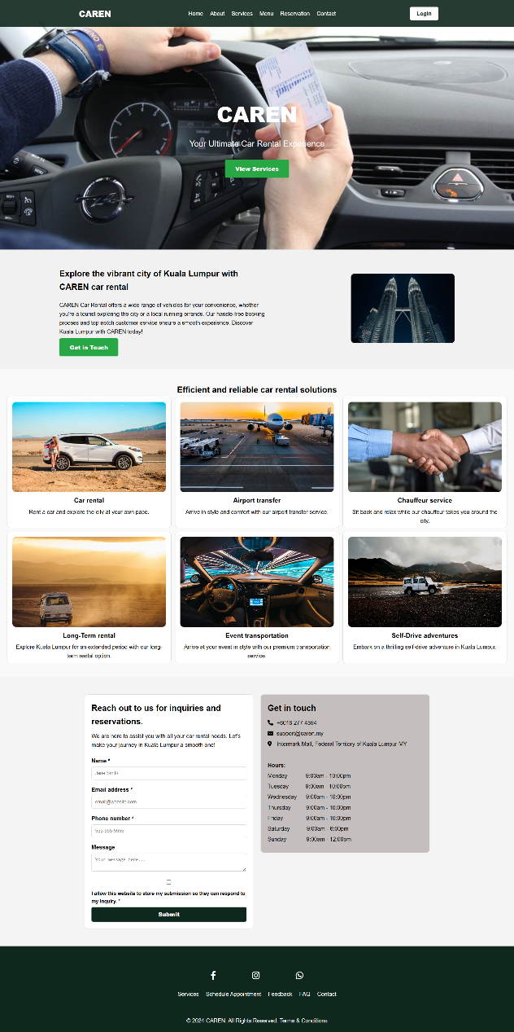

***Figure 4.1.1 Index Page***

This Car Rental website page includes a navigation bar with links to Home, About, Services, Menu, Reservation, and Contact, as well as a logo and a login button for user account access. The hero section includes a call-to-action button to view services which could redirect to the menu page. The discover section introduces car rental services, emphasizing the ease of booking and excellent customer service, along with a call-to-action button for users to get in touch. The services section displays various car rental options in a grid format, each with an image, title, and brief description. The contact section includes a form for inquiries and reservations, detailed contact information, and operating hours. The footer provides additional links, social media of the car rental, and copyright information.

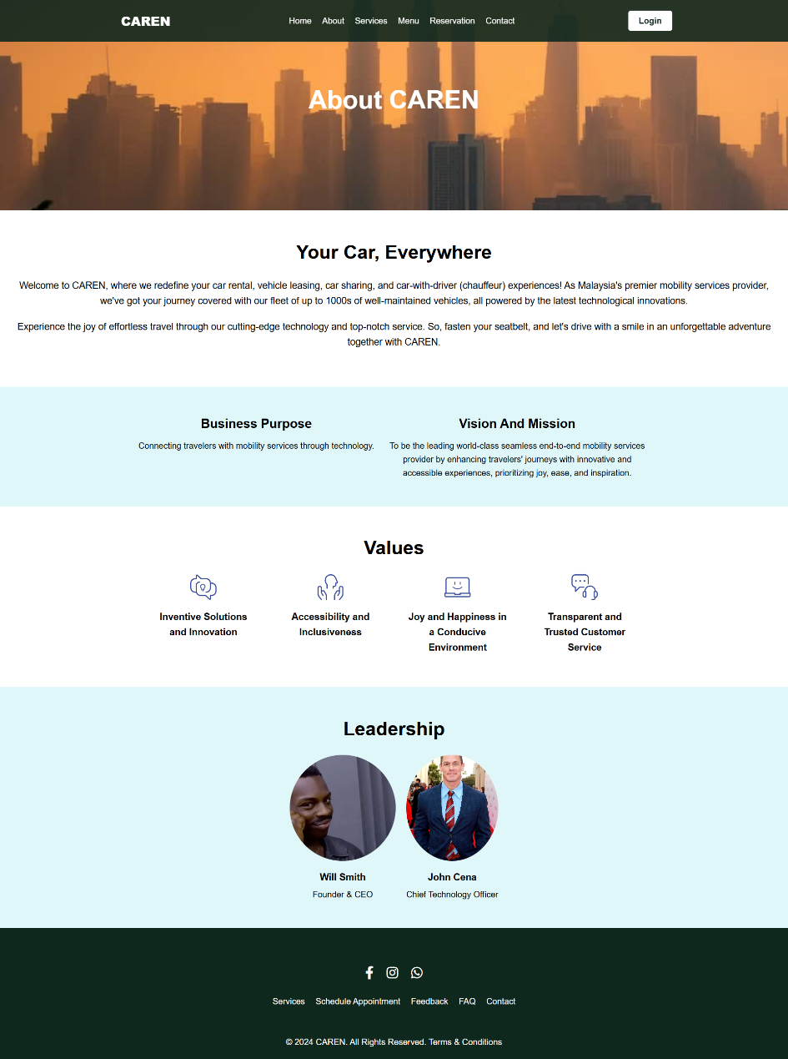

***Figure 4.1.2 About Us Page***

The About Us page of the CAREN website features a structured and informative layout designed to engage users. It starts with a navigation bar, including links to Home, About, Services, Menu, Reservation, and Contact, and a login button for user access. The hero section captures attention with a compelling background image and a welcoming headline. The introduction section provides an overview of CAREN's services, emphasizing innovation and top-notch customer service. The purpose section highlights the business purpose and vision, focusing on connecting travelers with mobility services. The values section showcases core values like inventive solutions, accessibility, joy, and trusted customer service, with visually appealing icons. The leadership section introduces key figures in the company, including the Founder & CEO and the Chief Technology Officer, with photos and brief bios. Finally, the footer includes social media icons and additional links for easy navigation, ensuring a comprehensive and user-friendly experience.

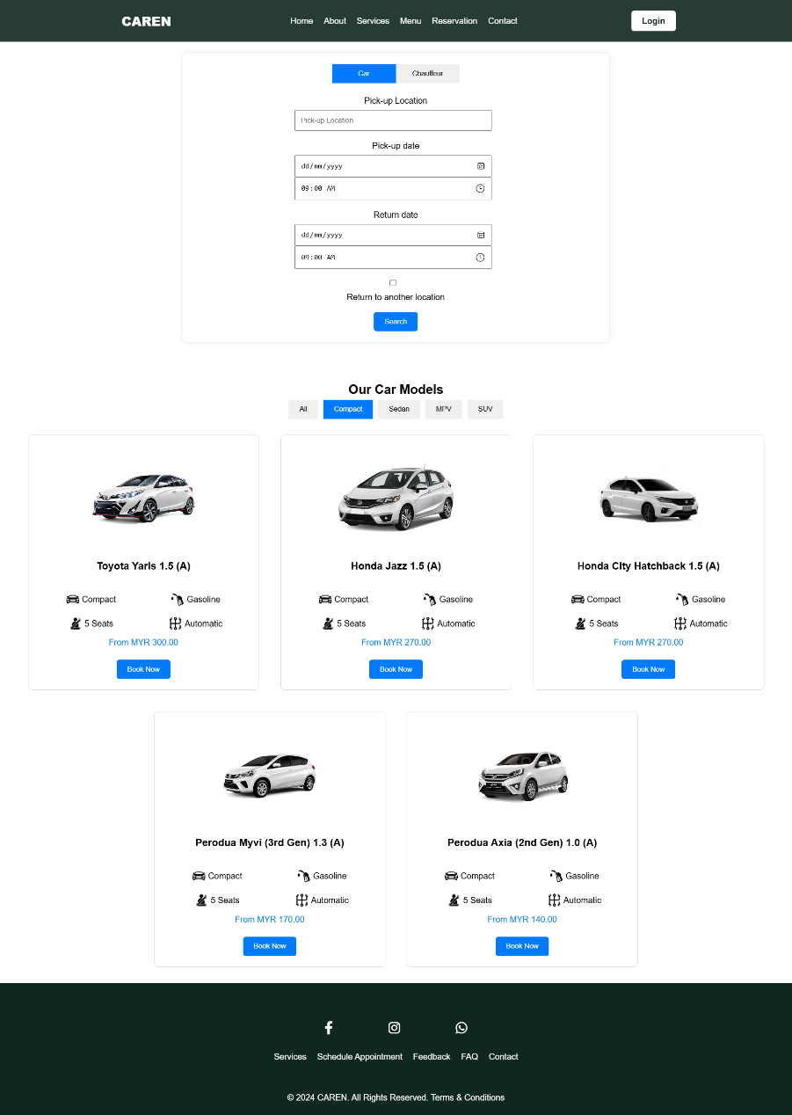

***Figure 4.1.3 Menu Page***

The Menu page is designed to provide a seamless and intuitive user experience for booking car rentals. It includes a navbar with links to essential sections like Home, About, Services, Menu, Reservation, and Contact, along with a login button. The form includes dynamic background images and a form container with tabs for selecting between car rental and chauffeur services. The forms allow users to input details such as pick-up and return locations, dates, and times, with an option to return the car to a different location. The main section displays various car models categorized into Compact, Sedan, MPV, and SUV, each with detailed features, images, and booking options. Users can filter cars by category using buttons that dynamically show or hide car items. The page includes a responsive design to ensure accessibility on different devices for interactive features like form validation, tab switching, and category filtering. The footer contains social media links and additional navigation options to further enhance user engagement and support.

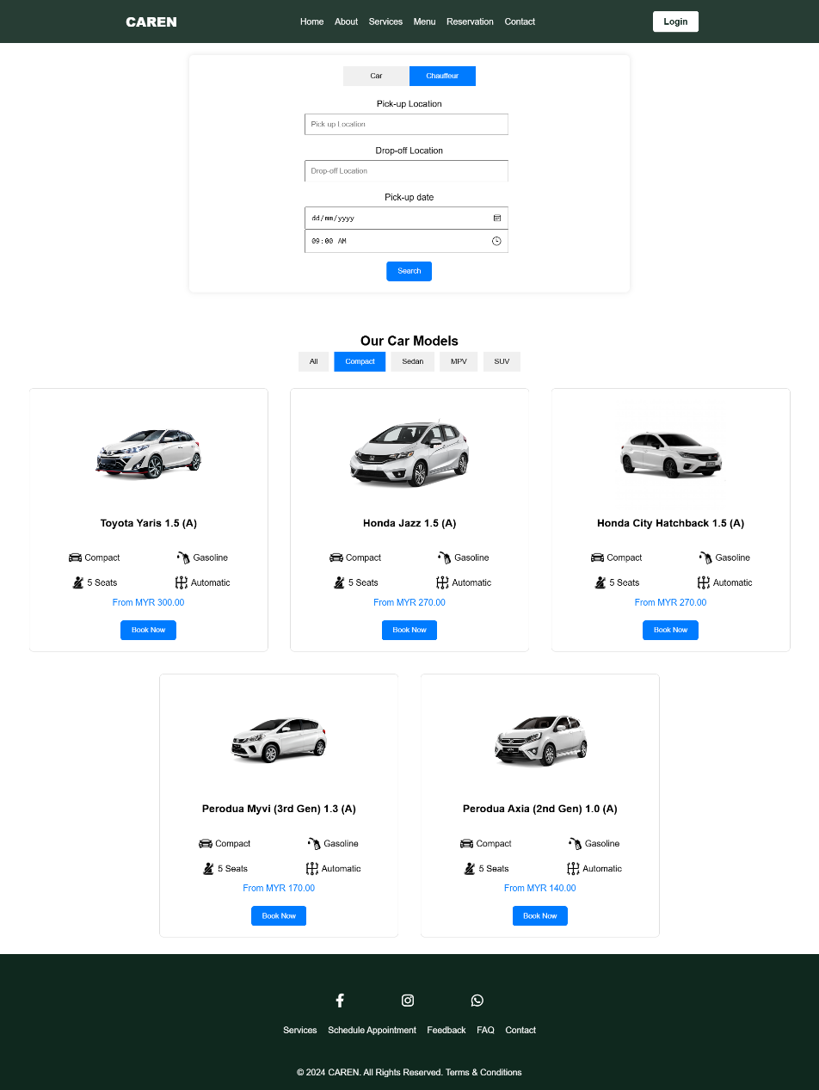

***Figure 4.1.4 Menu Page-Chauffeur***

The hero section includes dynamic background images and a form container with tabs for selecting between car rental and chauffeur services. The chauffeur forms allow users to input details such as pick-up, dates and times, after inputs all the fields and click search button, it will redirect to the Menu-Booking Page for choosing the vehicle.

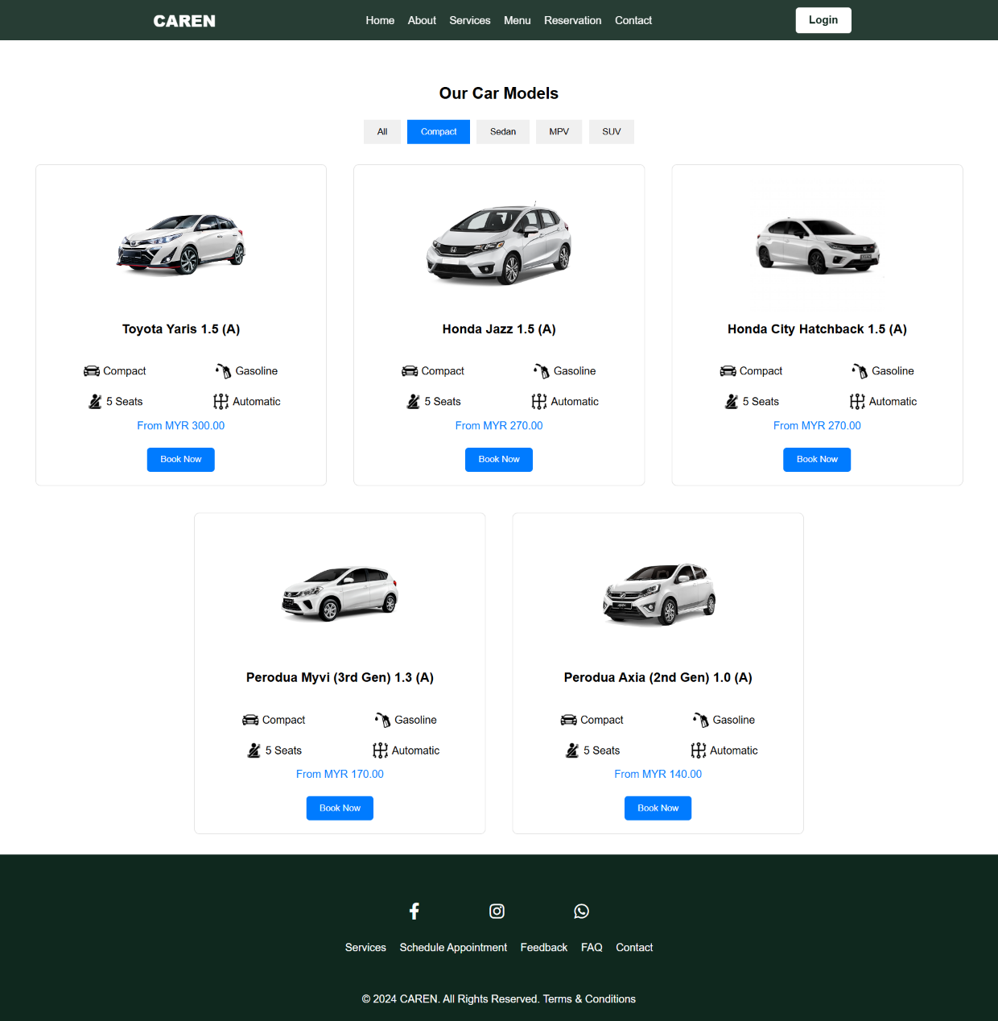

***Figure 4.1.5 Menu Page-Compact***

The main section displays various car models categorized into Compact, Sedan, MPV, and SUV, each with detailed features, images, and booking options. Users can filter cars by category using buttons that dynamically show or hide car items.

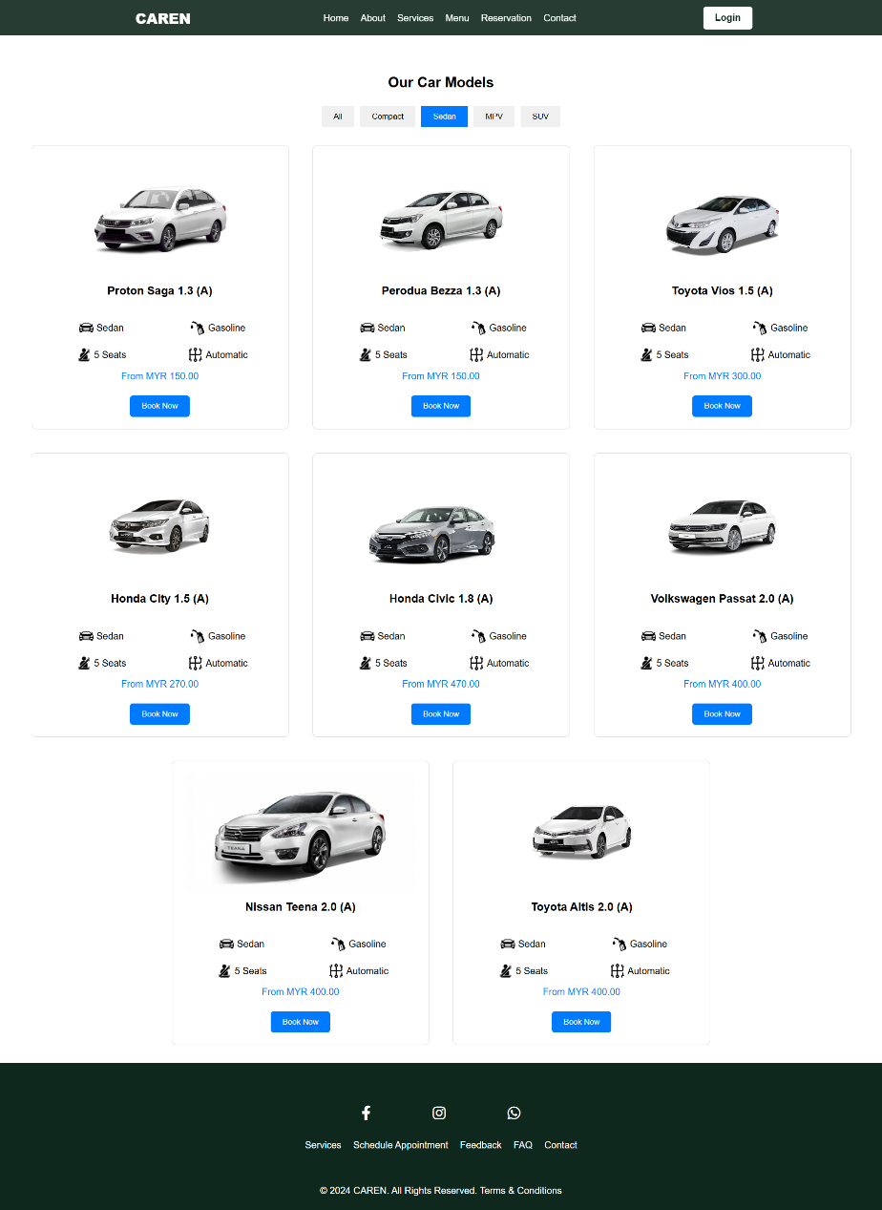

***Figure 4.1.6 Menu Page-Sedan***

The main section displays various car models categorized into Compact, Sedan, MPV, and SUV, each with detailed features, images, and booking options. Users can filter cars by category using buttons that dynamically show or hide car items.

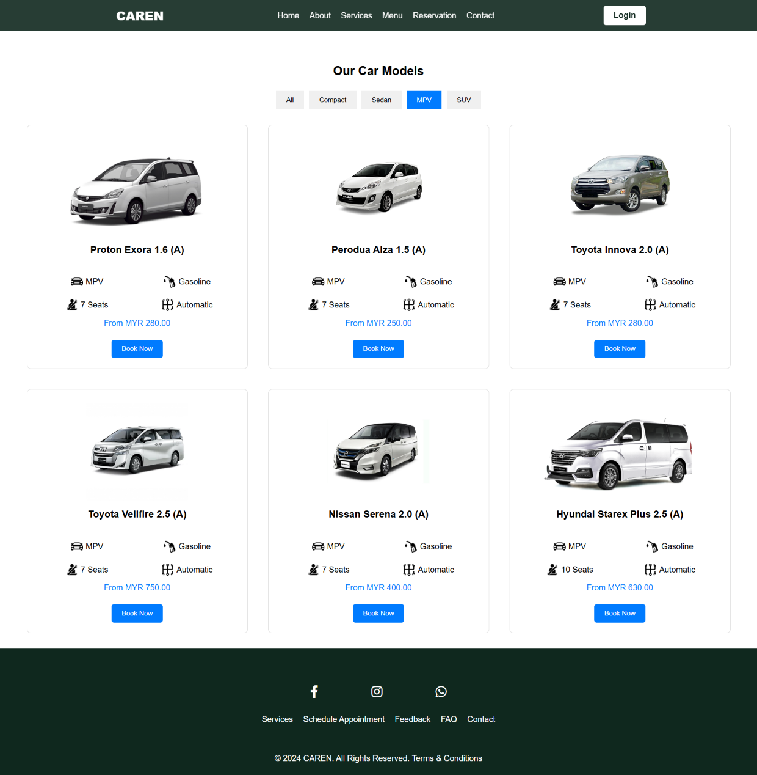

***Figure 4.1.7 Menu Page-Mpv***

The main section displays various car models categorized into Compact, Sedan, MPV, and SUV, each with detailed features, images, and booking options. Users can filter cars by category using buttons that dynamically show or hide car items.

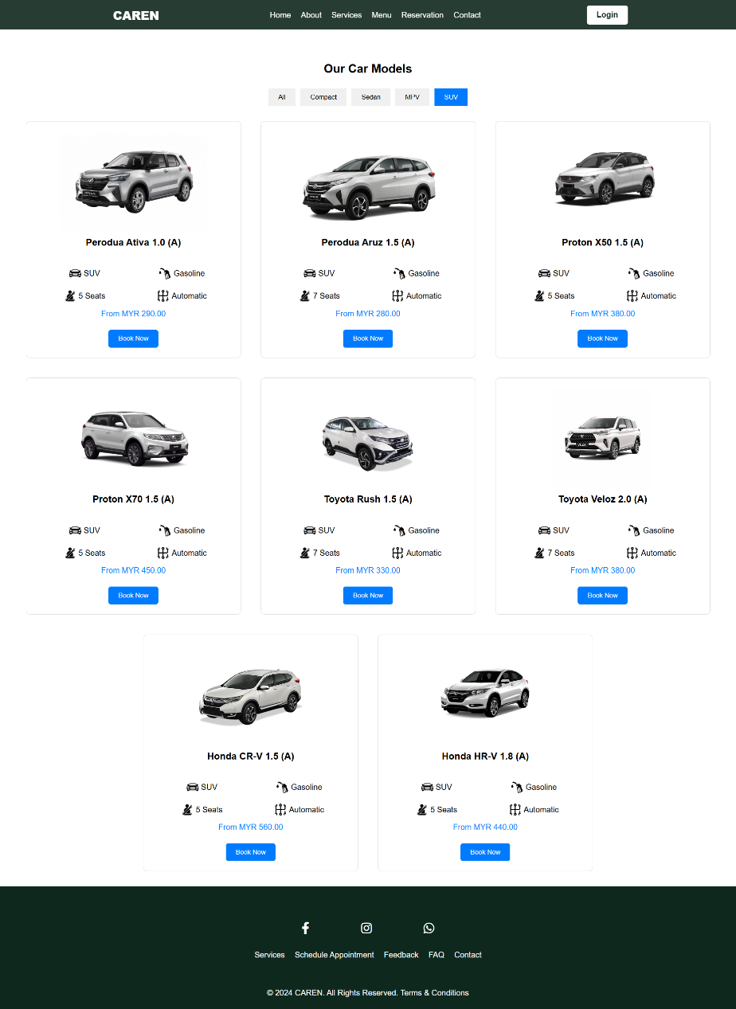

***Figure 4.1.8 Menu Page-Suv***

The main section displays various car models categorized into Compact, Sedan, MPV, and SUV, each with detailed features, images, and booking options. Users can filter cars by category using buttons that dynamically show or hide car items.

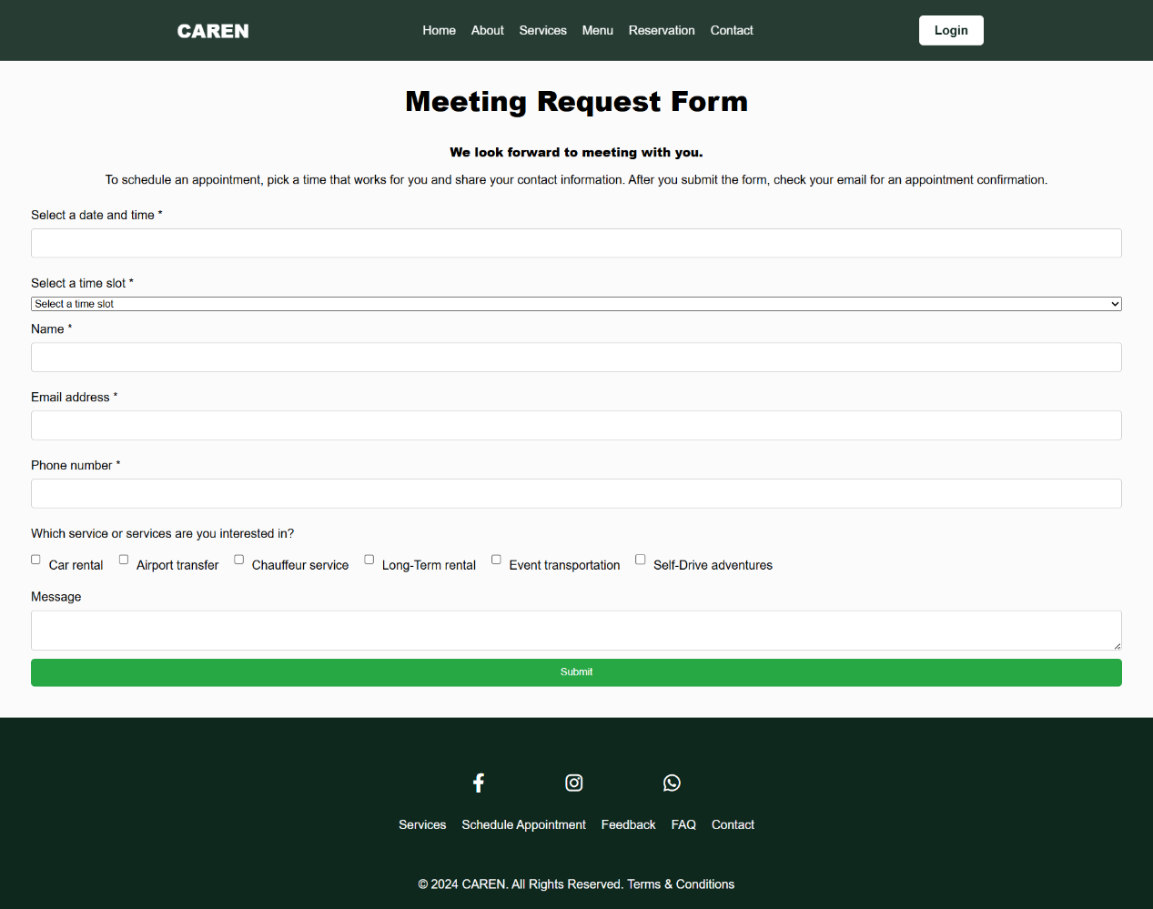***Figure 4.1.9 Reserve Page***

The Reservation page is designed to facilitate the booking of meetings and services efficiently. The page features a navigation bar with links to Home, About, Services, Menu, Reservation, and Contact, along with a login button. The main section is dedicated to a meeting request form that allows users to schedule appointments. It includes a date picker for selecting the desired date and a dropdown menu for available time slots, which dynamically updates based on the selected date. The form also collects essential contact information such as name, email, and phone number, and allows users to specify the services they are interested in, such as car rental, airport transfer, chauffeur service, long-term rental, event transportation, and self-drive adventures. Additionally, there is a message box for any additional information or requests. The footer includes social media links and additional navigation options, enhancing user engagement and support. The CSS ensures a clean and responsive design, while the JavaScript handles form validation and dynamic content updates, providing a seamless user experience.

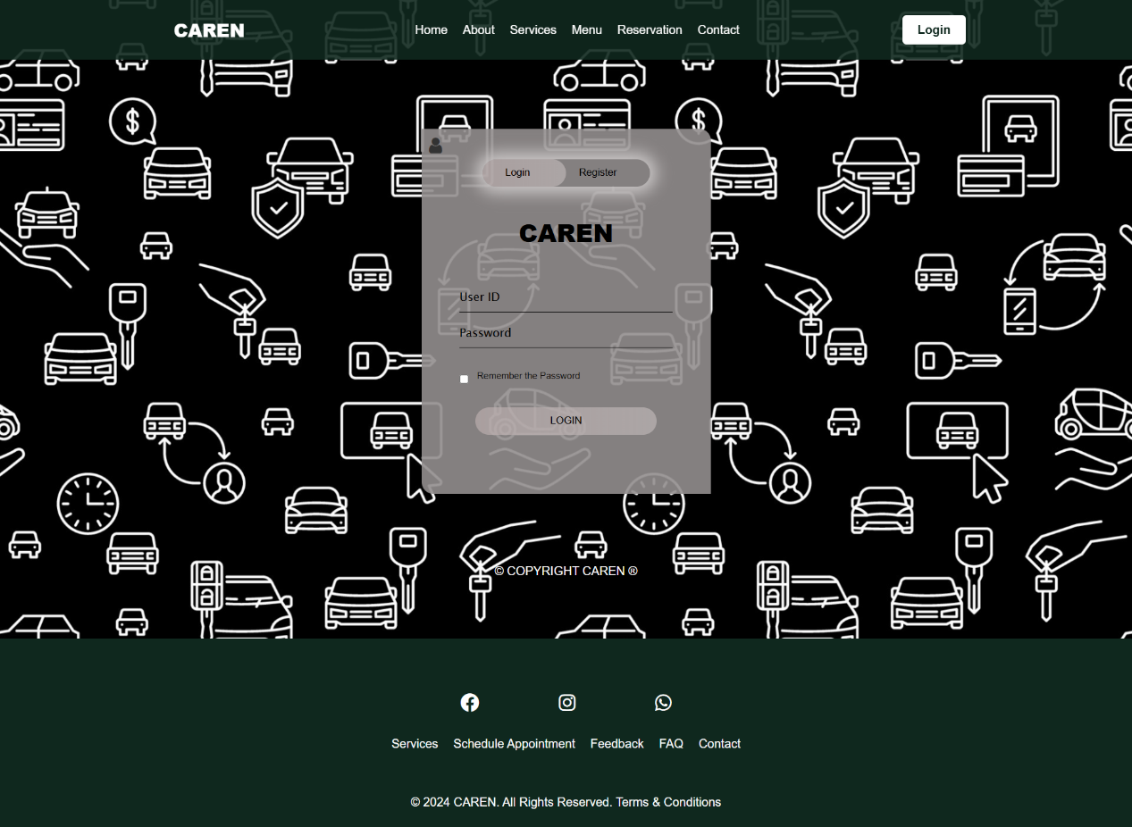***Figure 4.1.10 Login Page***

The Login page is designed to facilitate user authentication with a simple and intuitive interface. The hero section includes a visually appealing background image and a form container that allows users to switch between login and registration forms. The login form requires a User ID and Password, with an option to remember the password. The forms feature a submit button styled for easy interaction. The page employs a clean and modern design, with elements like a toggle button for switching forms, placeholders for input fields, and a form container styled with a gradient background and rounded corners. The footer includes social media icons and additional navigation links, enhancing user engagement and providing easy access to other parts of the website. The JavaScript functionality handles form switching and other interactive elements, ensuring a seamless user experience.

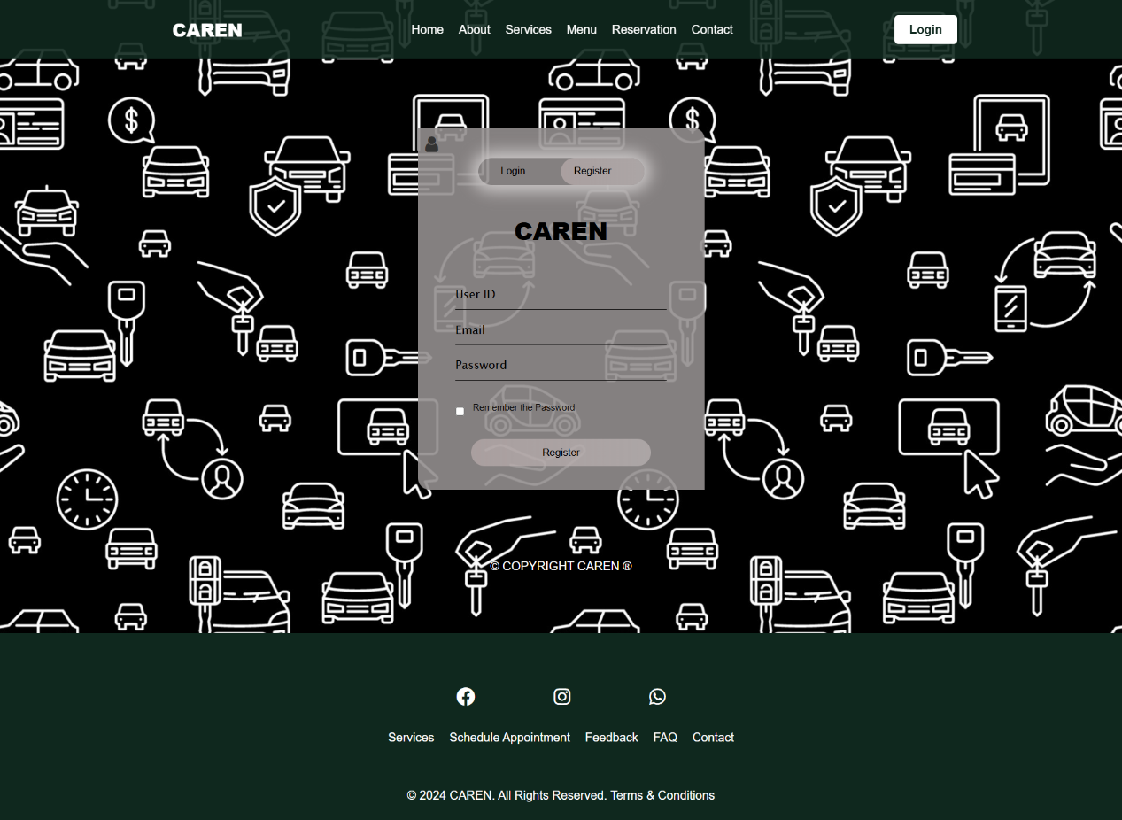***Figure 4.1.11 Register Page***

The registration form collects additional information like email and includes the option to remember the password. The forms feature a submit button styled for easy interaction. The page employs a clean and modern design, with elements like a toggle button for switching forms, placeholders for input fields, and a form container styled with a gradient background and rounded corners. The footer includes social media icons and additional navigation links, enhancing user engagement and providing easy access to other parts of the website. The JavaScript functionality handles form switching and other interactive elements, ensuring a seamless user experience.

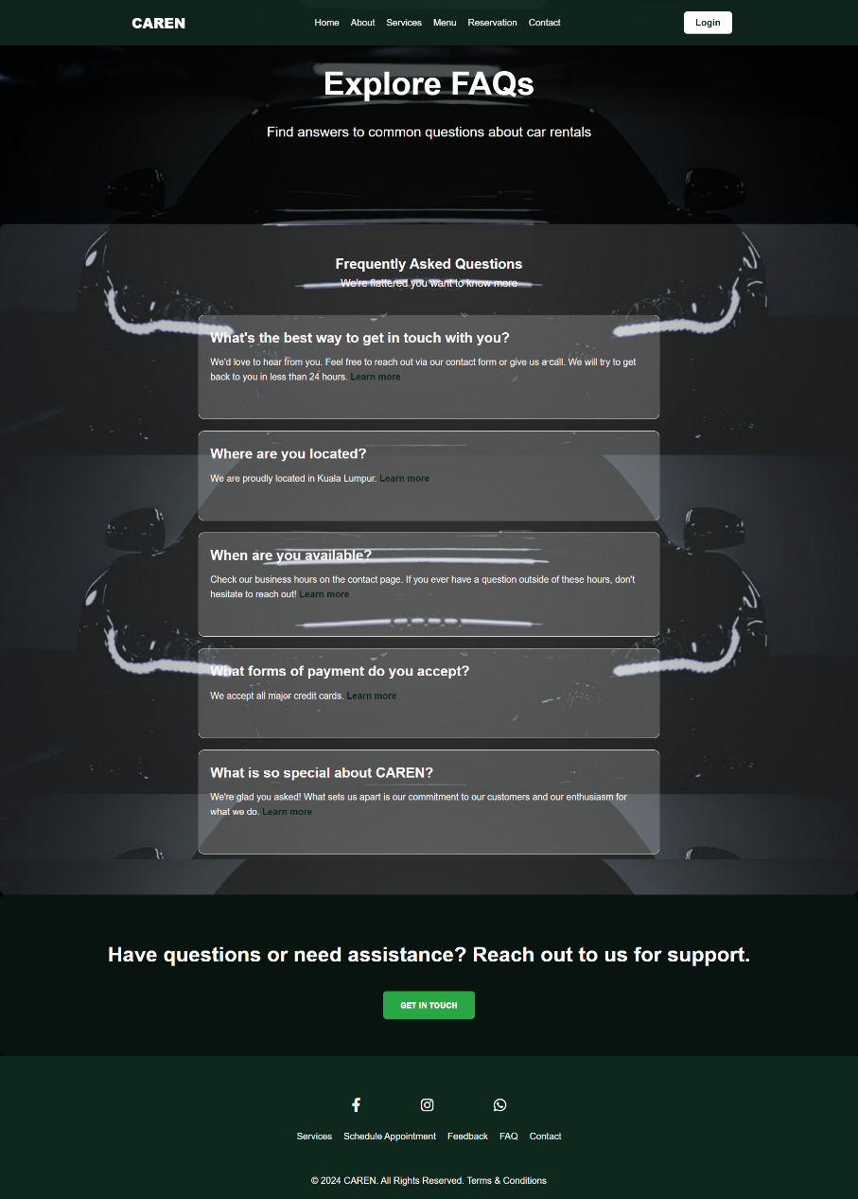

***Figure 4.1.12 FAQ Page***

The FAQ page offers a comprehensive and user-friendly resource for customers seeking information about car rentals. The page features navigation bar with links to key sections such as Home, About, Services, Menu, Reservation, and Contact, along with a login button. The hero section welcomes users with a bold headline and a brief introduction to the FAQ content. The main section is dedicated to frequently asked questions, organized in a clear and accessible format. Each FAQ item is presented with a question and a detailed answer, often accompanied by links for further information. The page's design employs a background image with a semi-transparent overlay to ensure text readability, and the overall color scheme is white text on a dark background for high contrast. The FAQ section itself is styled with light backgrounds for each question item, enhancing the visual separation and readability. The footer contains social media icons and additional navigation links, ensuring users can easily access other parts of the website or connect with the company.

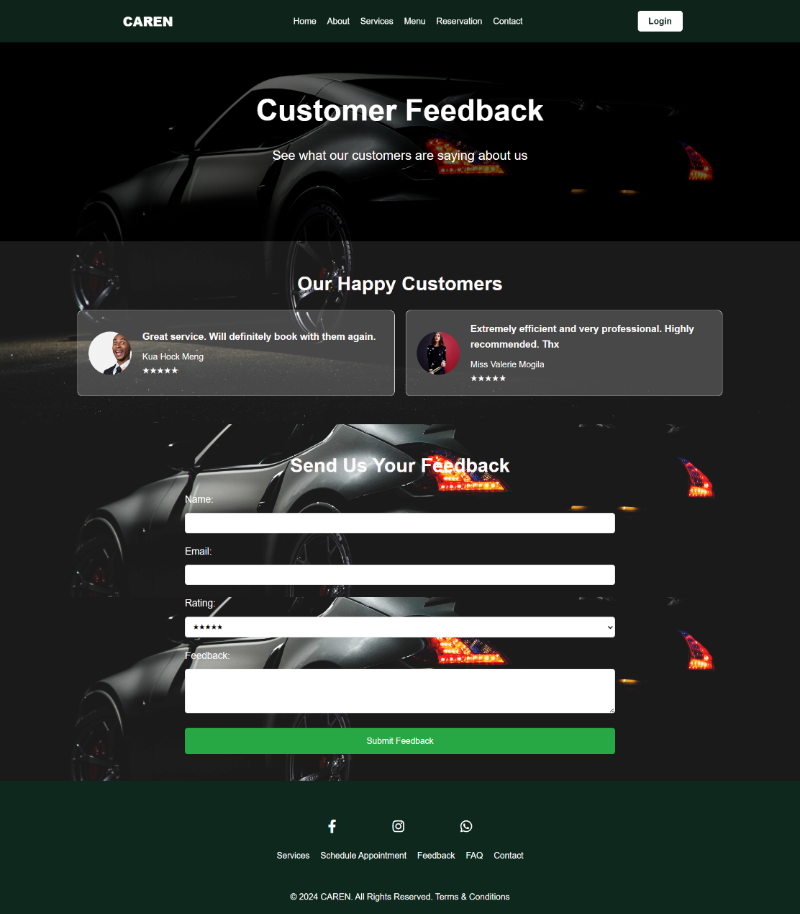

***Figure 4.2.13 Feedback Page***

Customer Feedback Page is a dedicated space for highlighting customer reviews and collecting new feedback. Upon entering, users are greeted by a stylish header with a fixed navigation bar, allowing easy access to Home, About, Services, Menu, Reservation, and Contact sections, along with a login button. The hero section prominently features a title and subtitle encouraging visitors to explore customer testimonials. The main feedback section is divided into two parts: a display of customer feedback and a form for submitting new feedback. The feedback display includes customer images, comments, names, and star ratings, presented in a grid layout for visual appeal and easy browsing. The feedback form allows users to provide their name, email, rating, and detailed comments, ensuring comprehensive feedback collection. The design employs a background image with a semi-transparent overlay, white text for readability, and modern styling elements like rounded corners and consistent spacing. The footer includes social media icons and additional links, providing further engagement opportunities and site navigation.

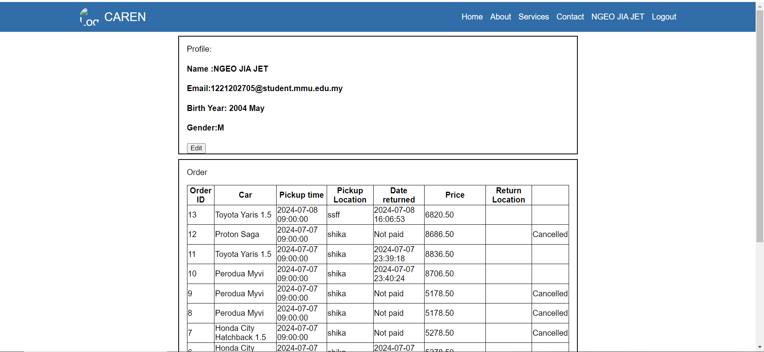**Figure 4.2.14 UserDashboard**

Users can view and return the car on this page and can edit the username.

**4.2 Admin/Staff/Front Desk Module**

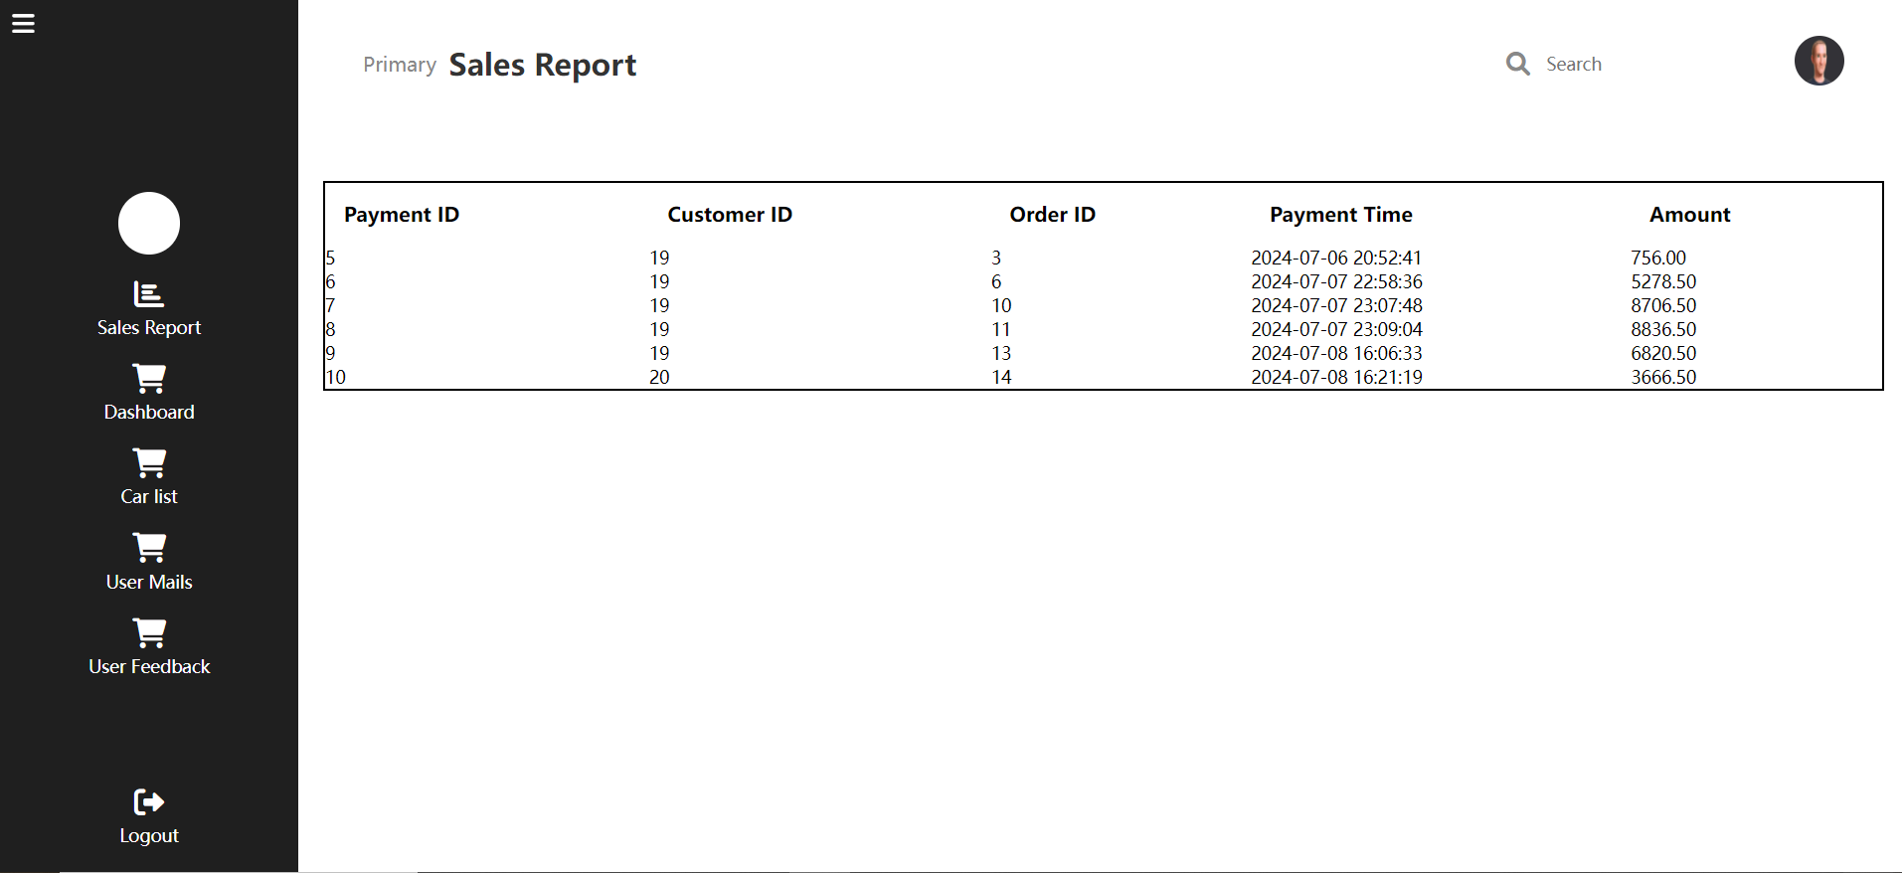**Figure 4.2.1 Sales Report**

This Figure shows the payment been marked by all customers.

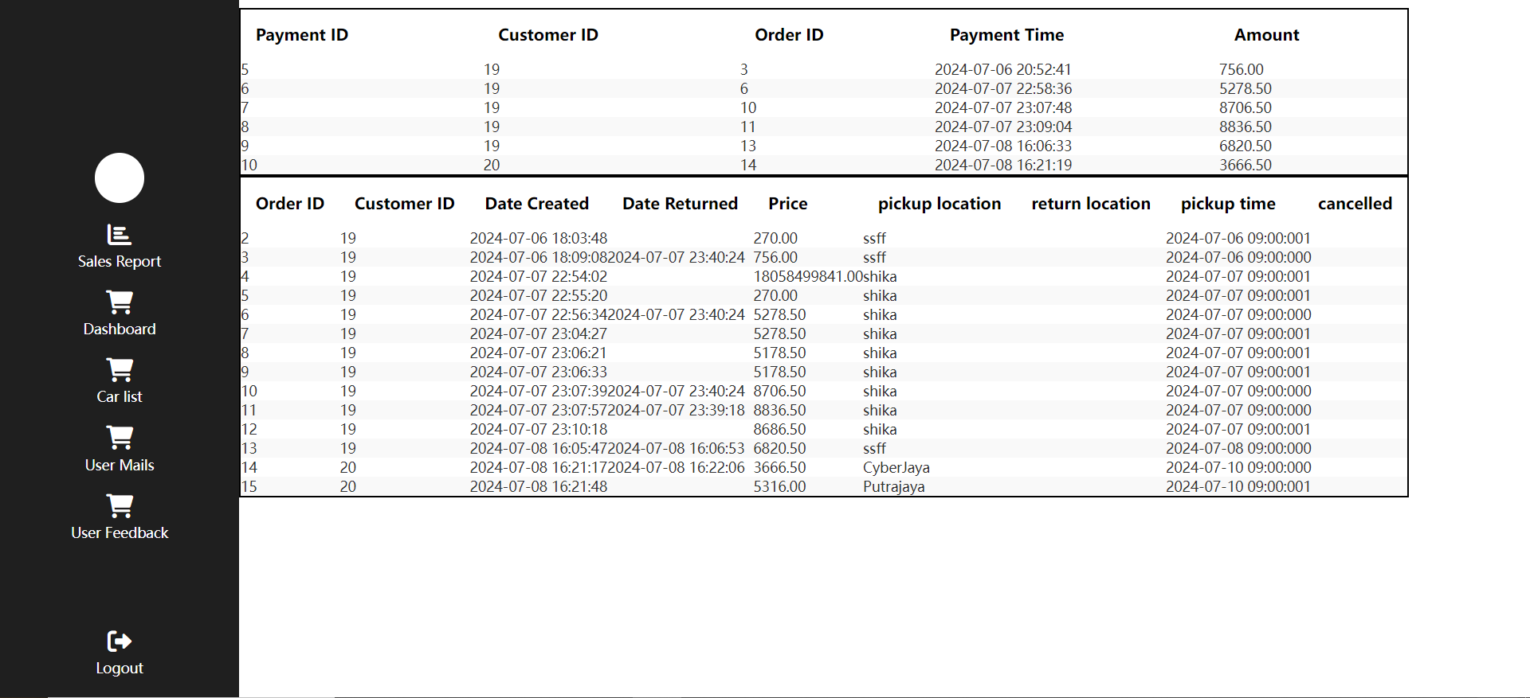**Figure 4.2.2 Admin Dashboard**

This figure shows that payment and order have been make.

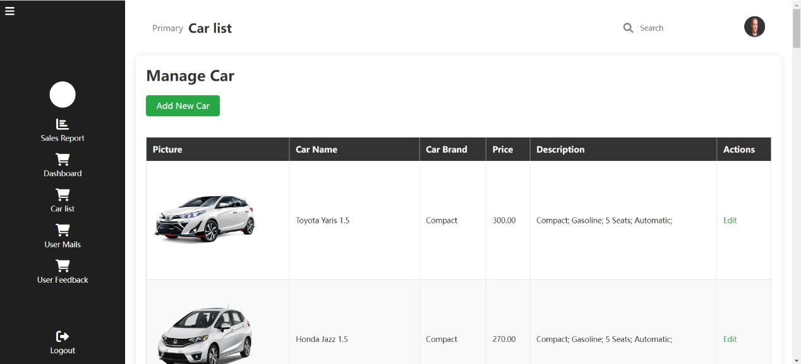**Figure 4.2.3 Add Car/Car list**

This figure shows the page of add new car and view the car list.

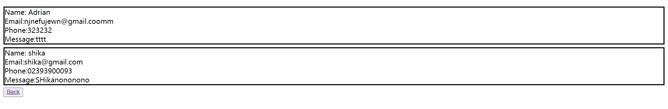**Figure 4.2.4 Contact Us**

This figure shows that the content been sent by customer using contact us form

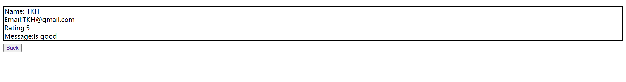**Figure 4.2.5 Feedback**

This figure shows that the content been sent by customer using feedback form

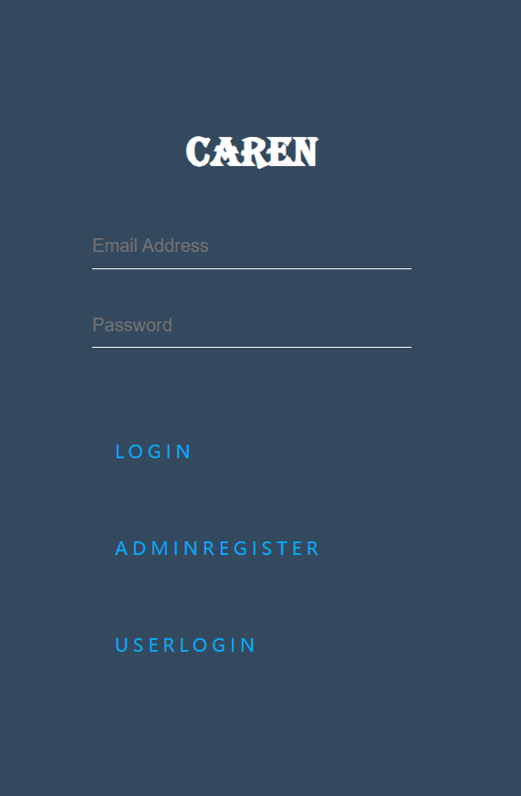

**Figure 4.2.6 Admin Login Page**

This page has been used to login to admin dashboard.

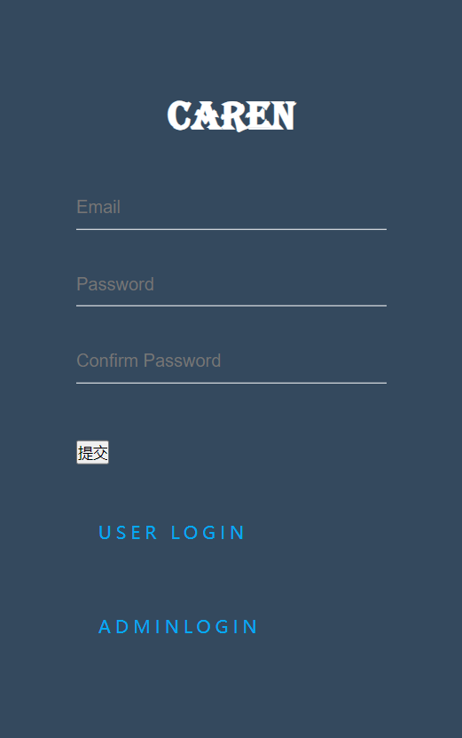

**Figure 4.2.7 Admin Registration Page**

Admin can fill in the info needed to register on here.

*Part V:*

*System Testing*

**5.1 System Testing**

This testing should cover functionality testing only. However you may include security testing or GUI testing. The system testing may be presented in a test plan (in a table form/checklist) that consists of functions to be tested, expected result and actual result. Then, you need to ***summarize the system testing***.

***Example:***

|  |  |  |  |  |
| --- | --- | --- | --- | --- |
| ***Test ID*** | ***Test Case*** | ***Expected Result*** | ***Actual Result*** | ***Status*** |
| *1* | *Login:*  *Enter valid username and valid password. Click “Login” button.* | * *Users should be able to login to the system.* * *The system should display home page with the name of the user.* | * *User is able to login.* * *Home page with name of user is displayed.* | *Pass* |
| *2* | *Login:*  *Enter invalid username and invalid password.*  *Click “Login” button.* | * *Users should not be able to login to the system.* | * *User is able to login.* | *Fail* |
| *3.* | *Register:*  *Enter valid username and valid password. Click “Submit” button* | * *Users should redirect to login page.* | * *Users redirect to login page.* | *Pass* |
| *4.* | *Register:*  *Enter invalid username and invalid password. Click “Submit” button* | * *Users could not register and prompt to re-input.* | * *Users cannot sign up and prompt to fill in the fields again.* | *Pass* |
| *5.* | *Index:*  *Click ‘View Services’ redirect to menu page and click ‘Get In Touch’ redirect to Contact form.* | * When users click ‘View Services’ will redirect to menu page * Click ‘Get In Touch’ will redirect to Contact page. | * When users click ‘View Services’ redirect to menu page * Click ‘Get In Touch’ redirect to Contact page. | *Pass* |
| *6.* | *Menu:*  *Select pickup or return location, date and time in Car Form or select pickup location, date and time in Chauffeur Form.*  *Filter car type for rental in the menu.* | * Users should be able to input pickup location, date & time, and select return location in Car From. * Users should be able to input pickup location, date & time. * Users should be able to filter car types in the menu. | * Users could input pickup location, date & time, and select return location in Car From. * Users can input pickup location, date & time. * Users able to filter car types in the menu. | *Pass* |
| *7.* | *About Us:*  *View the introduction of our website without any errors.* | * Users should be able to view our about page without any errors. | * Users could view our about page without any errors. | *Pass* |
| *8.* | *Reservation:*  *Input all the fields and click ‘Submit’ button.* | * Users should be able to input all the fields and select reserve time then submit the form. | * Users can input all the fields and select reserve time then submit the form. | *Pass* |
| *9.* | *FAQ:* *View all our FAQs without errors and click ‘Get In Touch’ button to redirect to contact form.* | * Users should be able to view our FAQs without errors. * Users could redirect to contact form after click the ''Get In Touch’ Button. | * Users can view our FAQs without errors. * Users will redirect to contact form after click the ''Get In Touch’ Button. | *Pass* |
| *10.* | *Feedback:*  *Watch reviews and write some feedback.* | * Users should be able to watch our previous customer reviews. * Users could write their reviews. | * Users could watch our previous customer reviews. * Users can write their reviews. | *Pass* |

*Table 5.1 -System Testing*

|  |  |  |  |  |
| --- | --- | --- | --- | --- |
| Test ID | Test Case | Expexted Result | Actual Result | Status |
| 1 | Register  -register an adminstrator account  Login  -Login an admistrator account | Account been record inside database and can be login | Admin able to login using the new registered account | Pass |
| 2 | DashBoard  -show the all order detail and payment detail | Order Detail and payment detail been show | Order Detail and payment detail been show | Pass |
| 3 | Sales Report  -show the all payment been registered in database | show the all payment been registered in database | show the all payment been registered in database | pass |
| 4 | Car list  -Add new car  -View all car | The car been display and be able to add car | The car been display and be able to add car | Pass |
| 5 | User Mails | Show the user message been submitted using contact us form | Show the user message been submitted using contact us form | Pass |
| 6 | User Feedback | Show the user feedback been submitted using feedback form | Show the user feedback been submitted using feedback form | Pass |

*Part VI:*

*Conclusion*

**6.1 Conclusion**

In this section,it is to wrap up what you have mentioned in previous chapters, and to sum up what you have achieved in this project.

To sum up, this project is web-based Car Rental System our group managed to achieve how to use the variant type of web development language such as PHP, HTML, JavaScript and CSS. We using these few languages manage to

create:

User:

Can login and register an account.

Can View and Rent the Car.

Can make a payment.

Can make an order and cancel the order.

Can edit the Username.

Can send the feedback form and contact-us form.

Can view the previous order.

Can return the car using User Dashboard.

Admin:

Can login and register as an administrator.

Can add the Car and view the car list.

Can view the payment in sales report.

Can view the All order in dashboard.

Can view the feedback form and contact-us form

*Part VII:*

*References*

List of URL addresses, reference books or bibliography entries

*Books:*   
Anti, J.M. and Ryan, P.V.S., “Civil Engineering Construction”, 3rd Ed., Sydney, Angus and Robertson, London, 1967, 631 pages  
  
*Journal:*   
Downs, R.B., “The Military Approach to Soil Stabilization”, *Journal of the Institute of Highway Engineers*, London, Volume XIX, No. 3, March, 1972, pg 19-23  
  
*Monograph:*   
Body, D.M., “Flood Estimation”. Water Res. Board of Australia. No.4, 1959, 41 pages

*Thesis:*   
Marques, J.L.G., “A Study of Anchorage Capacities of Confined Bentbar Reinforcement”. Ph.D. Thesis, Rice University, Houston Texas May, 1988  
  
*Conf.*   
Lea, F.M., “Cement Research: Retrospect and Prospect” in *Proc. 4th Proceedings*: *International Symposium on the Chemistry of Cement*, Washington DC, 1960, pg 5-6  
  
*Web Page:*   
Smith, A. B., “Description of the Intel P6 Processor”, Intel Corp.,   
<http://www.intel.com/pentium/p6/description.htm>

[Car Rental in Malaysia | Book A Car Online - WAHDAH](https://www.wahdah.my/)

*Working* Paper*:*   
Kuo, C and Sayer, P, “Education of Engineers in Marine Technology”, presented at the World Conference on Education in Applied Engineering & Engineering Technology Cologne German, 16-19 April, 1984  
  
*Standards:*   
British Standard Institute, “BS 6000:1972, Guide to the use of BS 6001, sampling procedures and tables for inspection by attributes”, London, 50 pages

[*https://www.w3schools.com/php/default.asp*](https://www.w3schools.com/php/default.asp)

[*https://www.w3schools.com/sql/default.asp*](https://www.w3schools.com/sql/default.asp)

[*https://www.w3schools.com/html/default.asp*](https://www.w3schools.com/html/default.asp)

[*https://www.w3schools.com/css/default.asp*](https://www.w3schools.com/css/default.asp)

[*https://www.w3schools.com/js/default.asp*](https://www.w3schools.com/js/default.asp)

*Part VIII:*

*Appendix*

**Appendix A: Meeting minutes**

All meeting minutes must be included in the report in the appendix section.

|  |  |
| --- | --- |
| Meeting Detail | |
| Name of the meeting | Team role & supervisor choice (short discussion) |
| Date | January 1st,2024 |
| Time | 11:00 am |
| Present Attendees | Ngeo Jia Jet, Teh Chi Siong and Loh Grierius |
| Absent Attendees | None |
| Agendas Discussed and Outcomes | |
| Agenda 1: Choose the leader in the group | Teh Chi Siong and Loh Grierius proposed Ngeo Jia Jet as a leader. |
| Agenda 2: Choose the supervisor | Teh Chi Siong proposed Madam Ruzanna .Ngeo Jia Jet and Loh Grierius proposed Madam Suraya as our group supervisor. |
| Meeting end time | 11:30am |

|  |  |
| --- | --- |
| Meeting Detail | |
| Name of the meeting | Project title |
| Date | January 7,2024 |
| Time | 11:00 am |
| Present Attendees | Ngeo Jia Jet, Teh Chi Siong and Loh Grierius |
| Absent Attendees | None |
| Agendas Discussed and Outcomes | |
| Agenda 1: Choose the project title | Ngeo Jia Jet and Teh Chi Siong proposed to do Car Rental System and Loh Grierius agree with this statement |
| Meeting end time | 1:00pm |

**Appendix B: Website Samples/Questionnaire/Forms**

Any website screen shots, questionnaires and forms used as reference to your project will be included in this section.

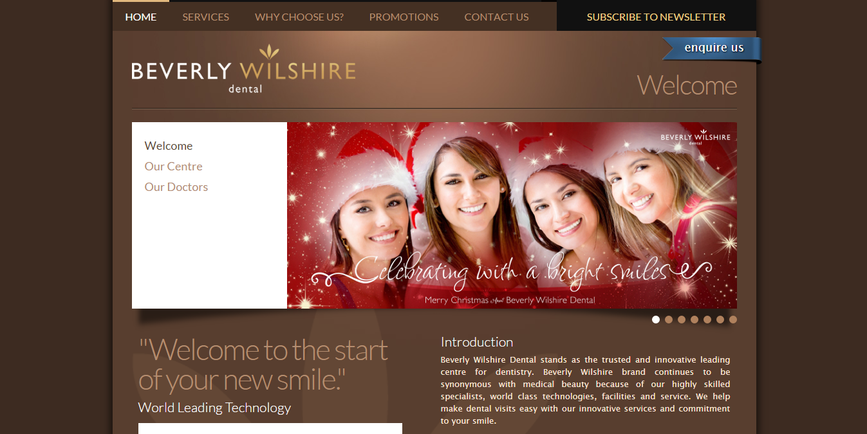

**Figure 4.1:** *Sample website screenshot*

**Appendix C: Request Interview Letter**

Students need to include the request interview letter if they have conducted an interview session.

**Appendix D: Interview Questions**

Students need to include the interview questions if they have conducted an interview session.

**Appendix E: Client/Server Setup Guide**

This section should provide the user manual for user and administrator in terms of:

* Hardware configuration or setup
* System Integration Manual
* Installation Procedure

[FYP USER MANUAL](https://mmuedumy-my.sharepoint.com/:w:/g/personal/1221202705_student_mmu_edu_my/ERO1DXShs1xImpaqEuBNrMIBEyNvqMf3zC8KbfU586EQ0g?e=KBSLXp)

**Appendix F: CD (Softcopy of Report and System)**

Attach the CD that contains the softcopy of the report and also the system.